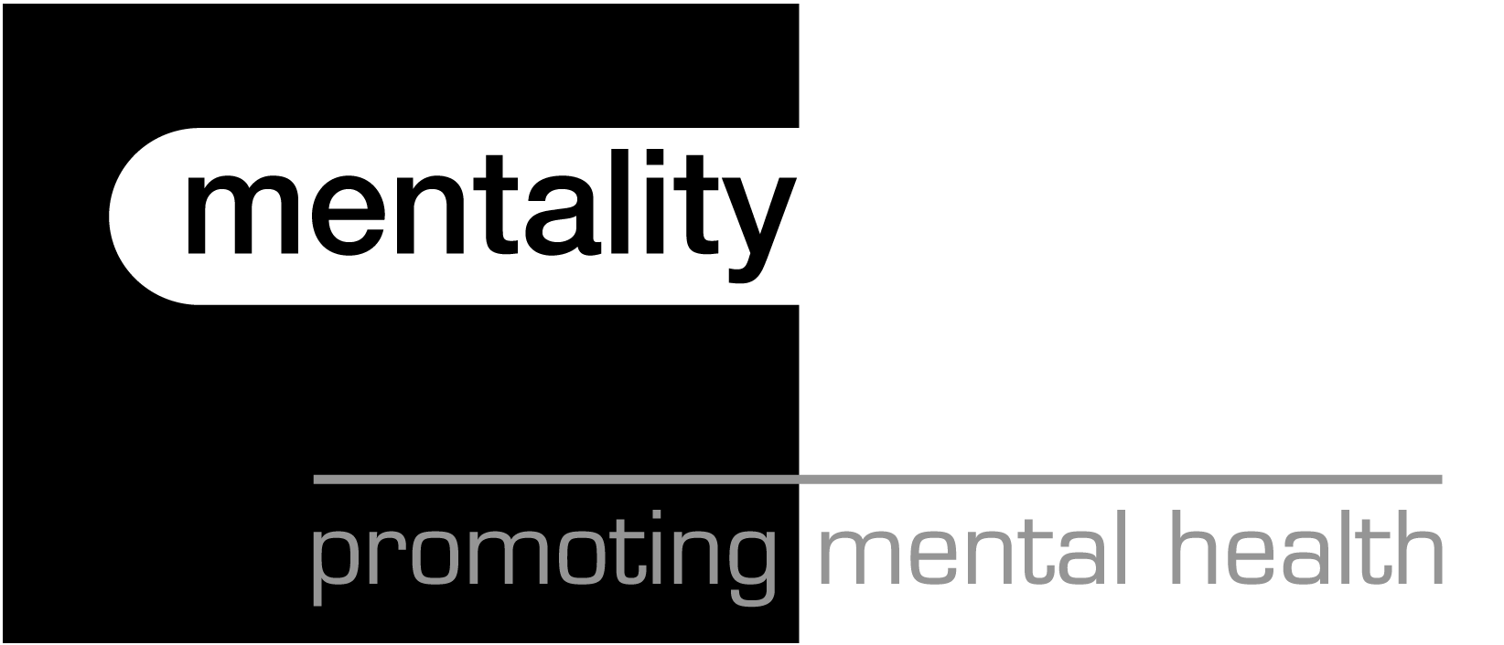

Department of Health

Working Well Programme

Executive Summary

Introduction

The Working Well programme was funded by the Department of Health and managed by mentality, the national charity dedicated solely to the promotion of mental health. The programme aimed to consider the impact that stigma relating to mental health had on professionals working in mental health services. There is an extensive literature on the stigma and discrimination experienced by people with mental health problems but little, if anything, has been researched or written about the impact this has on the staff working within these services. In 2001 the Workforce Action Team noted that the effect of stigma on recruitment, retention, status and morale in mental health services had not been examined. The Working Well programme aimed to start the process.

The final report of the programme covers the policy context, an extensive literature review and the findings of the primary research completed by mentality. This research included quantitative data from a MORI survey of the general public and qualitative data from three regions London, Eastern and the East Midlands. The research included one to one interviews and focus groups with professionals working within services and further focus groups with professionals working in human resources and with users of mental health services. The research was completed between December 2001 and May 2002.

Policy Context

There is a range of challenging new priorities and policies outlined in recent Government documents which staff within mental health services are tasked to deliver. The NHS Plan, Modernising Mental Health Services, Modernising Social Services and the National Service Framework for Mental Health all recognise the importance of attracting new members of staff and supporting and retaining current employees to deliver effective mental health services.

There are also a growing number of workforce policies to support staff within health and social care environments. These include Working Together, the first human resources framework for the NHS and Improving Working Lives, which sets standards for good HR practice across the NHS. The Improving Working Lives standard aims to support the creation of a well managed flexible working environment that supports staff, promotes their welfare and development and provides a productive work-life balance.

Literature Review

The published literature does not support the hypothesis that stigma is a deterrent to joining the mental health workforce. Rather the common drivers focus largely on personal experience such as having had exposure to mental health services and the impact of positive student placements.

Vocational themes emerge from the literature such as the desire for individuals to make a difference and to make a positive contribution to society. Also gaining satisfaction from client contact, having the opportunity to work with people and the ability to tolerate the ambiguity of psychiatry and the treatment of mental health problems have been considered to be important as motivating factors.

Stereotypical views of health professionals have been found to be important in shaping public opinion. Where stereotypes are positive, such as general nursing, they have been shown to have a positive impact on recruitment also. However some negative stereotypes, such as poor images of social workers, may also have a negative impact, which is compounded by negative media coverage.

Stigma also does not appear in the literature to be a factor which leads to the high attrition rate currently for staff within mental health services. The literature instead provides a range of reasons for the retention problems within mental health services including low morale, increased job dissatisfaction, professional isolation and increased levels of stress. Some studies also point to the negative impact of changing philosophies and practice of care provision, increased paperwork, increased caseloads, staff shortages and poor supervision. Finally the lack of career progression paths are identified as impacting on poor retention figures particularly the lack of opportunities to progress without losing all clinical contact.

Summary of findings

Views of the General Public

In a survey of the general public conducted by MORI mentality tried to gain information on the views of the general public towards people working in mental health services. 53% of participants believed that mental health professionals did a good job (26% not knowing), 56% of participants respected professionals who work with people with mental health problems (10% not knowing) and 46% of people would recommend working in mental health services as a career (10% not knowing).

Views of Mental Health Professionals

Professionals working in mental health services generally believed that the stigma related to working in services was negligible compared to that experienced by service users. They therefore did not rate its impact on recruitment and retention, however these were individuals who had chosen to work within services themselves.

Participants recognised the high levels of stigma experienced by people who had used mental health services. There were two main reasons given for this: firstly the poor portrayal of people with mental health problems in the media and the constant links to violence and crime. Secondly, the general lack of information and the low level of knowledge and understanding among the general public regarding the nature of mental health problems was viewed negatively.

Participants felt that there was a stigma within health professions about mental health. These inter-professional attitudes were felt to be damaging to those working within mental health, who believed general colleagues saw them as ‘tainted’, ‘infected’, or less able or less ambitious.

In terms of recruitment positive student placements were mentioned by nurses, occupational therapists, physiotherapists and social workers as being key to their decision to pursue a career in mental health.

Broadly staff felt that working in mental health was a positive career choice. Many participants believed their careers were vocational in nature and the most positive thing about their role related to teams and colleagues with whom they work. Individuals working in mental health services were seen to have different skills and attributes from professional peers, which were highly valued by colleagues, some mentioned an increased psychological awareness and a desire for personal fulfilment. Also mentioned was the rewarding nature of careers and the ability to be more creative, more flexible and more empowering working with mental health services. Also participants mentioned the positive impact of working directly with people with mental health problems.

Negative aspects relating to the retention of staff included the ambiguity of specific job roles and responsibilities, particularly in relation to working within teams. Also participants mentioned the professional isolation often experienced, as the only occupational therapist or social worker on the team for example. This also has an impact on the development and progression within roles which was also viewed negatively for staff retention. Unrealistic or overwhelming workloads were mentioned as increasing stress among staff and these were exacerbated by the general problems with recruitment, impacting on remaining staff.

Participants also mentioned the low morale of staff working within mental health which was contributed to by a feeling of not being valued. Low pay, poor conditions, often lack of flexibility, particularly in relation to managers, policy-overload from Government, changing priorities and the constant agenda of change were also mentioned as having a negative impact on staff working in mental health services.

Many participants mentioned the culture within which they deliver mental health services currently being negative on their practice and their levels of job satisfaction. It was felt that the current system concentrated on risk assessments and a tick box culture where individuals were expected to ‘cover their backs’ in case of inquiry or investigation. This frustrated many staff who saw a direct link between increased bureaucracy and the reduced time they have to spend with clients, which they find most satisfying.

Views of Human Resources Professionals

The human resources professionals interviewed worked in mental health services and all recognised the stigma associated with mental health. They believed that this stigma had a direct impact on recruitment but not on retention of staff working in mental health services.

Participants recognised that stigma had an impact on recruitment as people would not wish to work in an area which they may consider ‘unsafe’ or ‘frightening. They also believed recruitment into mental health among health professionals had been affected by the low priority that was historically given to mental health. Although it was recognised that this had now changed participants felt that it would take a considerable period of time before the impact of this change was felt within services.

Human resources professionals recognised the problems with retention, particularly in inner-city areas, however they felt that staff mainly left a service rather than leaving the profession. This was seen as due to personal circumstances rather than the stigma of working within a specific service area. Within services the key issues which they felt had an impact on people leaving mental health services related to supporting and valuing staff. Two main issues mentioned were firstly, poor management due often to lack of management and leadership training for clinical staff, which was not always considered to be a priority. Secondly, poor pay and conditions for staff which was seen to have a detrimental effect over time for staff retention levels.

Views of Mental Health Service Users

Participants who had experience of using mental health services agreed with professionals that the stigma which related to mental health was concentrated on those who experience mental health problems, rather than services or people working within services. Participants accepted that this had an impact on the nature of the services, due to the poor public perception of community care and the impact this has on individuals seeking help.

Participants felt that the general public had a very low level of understanding of mental health problems. They believed the most positive attitudes were among those who may have had contact with people with mental health problems and this included staff. The public’s attitude was considered to be one of preconceived danger and fear of violence. Participants believed that the general public may admire people working in mental health services, considering the difficulty of the job or the wish to work with ‘those people’.

People with experience of using services believed that staff were the backbone of any effective service or practice. However they recognised that often staff and people with mental health problems had different views of what that meant, particularly when relating to issues such as confidentiality, rights and responsibilities. They recognised the frustrations of staff with the system, such as lack of finance or increased bureaucracy, led to them becoming demotivated.

Participants also recognised the problems of recruitment and retention within services. They considered problems with recruitment impacting on the current staff, increasing workloads which are often already high and reducing staff and client contact. They considered problems with retention impacting on the current staff, increasing the number of bank and agency staff used. This was also seen to have an impact on the services received, particularly in inner-city areas. People found the constant requirement to meet new staff, update them on your medical history and preferred treatment options deeply frustrating. This had an impact on how individuals are monitored and how valid they believe professionals views are.

Conclusion

The Working Well findings, both from the literature and from the research, show overwhelmingly that there is a strong stigma associated with mental health. However the stigma does not appear to be associated with working in mental health services, far more so the stigma is linked to those people who have used the services.

However the stigma associated with mental health is seen to have an impact on mental health professionals indirectly and their practice directly. Stigma was seen as one factor in the lack of resources allocated to mental health historically and the lack of status for professionals working within the mental health system.

This broader stigma was also seen to have led to disproportionate levels of concern about violence and an overemphasis on safety and defensive practice for staff. It has led to professionals believing they work in an Inquiry driven area, leading to a pervasive blame culture, where people are encouraged to ‘cover their backs’ and ‘tick the bureaucratic boxes’. This in turn is contributing to poor levels of job satisfaction and low morale among staff as it directly reduces the amount of time staff spend with clients.

Recommendations for ensuring that staff within mental health services continue to work well include investing in broad community programmes to reduce stigma and increase the social inclusion of people who have used mental health services. Specifically for staff programmes should be implemented that will value the workforce, support individual members and improving working conditions for all.

On the Impact of Stigma on Services
“We have developed very safe practice, very defensive practice. The culture is don’t take any risks, make sure your paperwork is done and if you’ve got a choice of paper or person – go for paper. It’s very frustrating.” Participant – East Midlands

On Public Attitude to Staff
“Psychiatrists make you lie on a couch, male nurses are all gay or sadists or possibly both, OTs make fluffy bunnies and baskets, social workers section people and take your children away. What that kind of image being portrayed it’s ever so easy to blame somebody when something goes wrong.” Participant – Eastern

On Recruitment of Staff
“It’s not about spending money to change perceptions, to challenge stigma in any way shape or form that’s the wrong way of going about things. To get people in you have to spend money on really improving the services. Making them an attractive place to work. Participant - London

On Retention of Staff
“It’s not the stigma of services that pushes people away or makes people leave…… it’s no different in mental health than anywhere else…..It’s what are the good bits of my job and what are the bad bits and when the bad bits start to outweigh the good bits I think they cause people to leave the service and the system.” Participant – East Midlands

